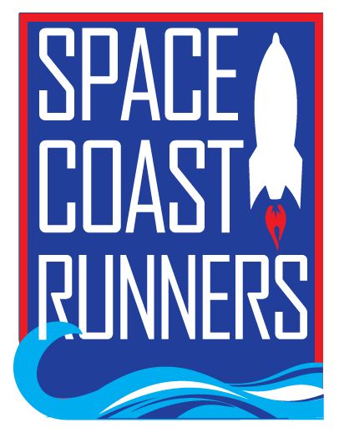 Space Coast Runners Scholarship 2021
Space Coast Runners (SCR) is a nonprofit organization whose purpose is to promote fitness, through running and walking at the community level in Brevard County. Space Coast Runners will award scholarships to two high school seniors in the amount of $2,000 each; students must be a member of their school’s cross country and/or track team and/or a member of Space Coast Runners. Applicants will be evaluated on the strength of a 250-word essay that addresses the prompt, “What life skills have I learned through running that will serve me in college.”
Applicants should fill out the information below and email it along with the essay to Marisa Flint at flint4@bellsouth.net no later than February 28 2021. Scholarship winners will be notified in mid-March. Winners are expected to attend the SCR dinner in June and read the winning essays (this year, instead of a dinner there may be virtual presentations and social media posts, depending on pandemic restrictions.)

Student’s Name _______________________________________________________________________
Last First
Address ________________________________________________________________________
Street City Zip code
Phone ______________________________________________________________________________
Email ______________________________________________________________________________
School ______________________________________________________________________________
GPA __________ Class rank___ Guidance counselor signature_____________________________
Please list any extracurricular activities in which you participate:

University you plan to attend, and major:

What would you like the SCR scholarship committee to know about you?

