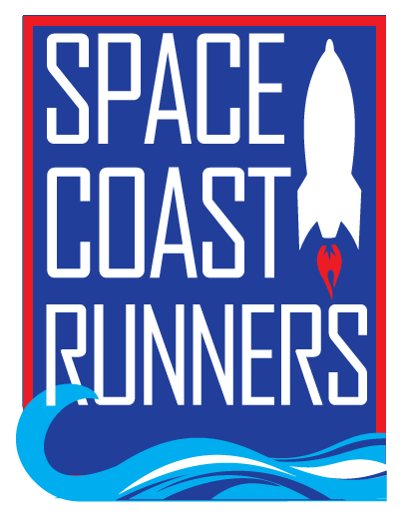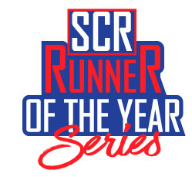 | SPACE COAST RUNNERS  YOUTH RACING TEAM APPLICATION  2022-2023

SCR Youth Racing Team Application (application submission deadline is 5/27/2022)
Name: |  |  |  |  |  | DOB:
Address:
 | City |  |  |  | State |  |  | ZIP Code
Phone: |  |  | Email:

Current SCR Member? Yes ____ No ____ Occupation: ___________________________________________

Current Age: _____________________ Favorite Race: ___________________________________________

Facebook Handle: __________________________________________________________________________

Singlet Sizing: ____ Men ____ Women | Sizes: XS ____ S ____ M ____ L ____ XL ____ 2XL ____

Jacket Sizes (unisex): | XS ____ S ____ M ____ L ____ XL ____ 2XL ____

APPLICATION INFORMATION
An application committee will be formed to select team members based on the following criteria:

- Commitment to SCR
- Application responses
- Assessment of SCR team and club representation

I have read and understand the selection criteria: ____ Yes ____ No

TEAM REQUIREMENTS
- Have a current membership with the Space Coast Runners
- Be between ages 8 and 18 (must still be in high school)
- Register and run/compete in at least 6 SCR 2022-2023 5K ROY races. If the race includes a team category, members will register as “SCR Youth Racing Team”.
- Participate in team fun runs
- Volunteer at SCR Youth Series events
- Have a parent/guardian at all races or team events
- Consent to use of image for marketing purposes.
- Sign a Code of Conduct and Sportsmanship agreement for both child and parent/guardian
Note: Youth Racing Team members who do not satisfy requirements may be removed from the program

I have read, understand and agree to meet or exceed all team expectations: ____ Yes ____ No

QUESTIONS Attach answers to application.
- Why do you want to participate on the SCR Youth Racing Team?
- Describe a running related accomplishment, memory or interesting story. (If selected for the team, this will be used for introductions in SCR promotions, social media, etc.)
- Do you have any questions or concerns about the SCR Youth Racing Team?

PLEASE SIGN By signing below, I certify all information is true and correct.

Signature of Applicant: _______________________________________________ Date Signed: ________
SUBMIT APPLICATION TO: RACINGTEAM@SPACECOASTRUNNERS.ORG

