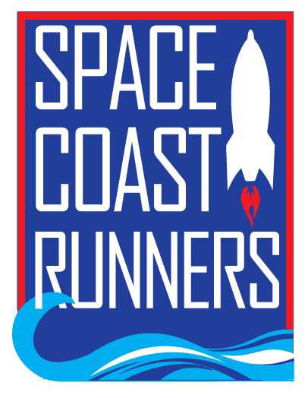

SPACE COAST RUNNERS
MINUTES OF May 2024 MEETING
6:30 PM EST – In Person Meeting
St Francis Reflections Board Room: 6905 N. Wickham Rd., 3rd Floor.
Monday, May 20th, 2024

Board Members / Officers Present: Terry Ryan (President), Brittany Streufert (Director of Operations), Galyn Sehnk (Vice President), Chris Kelly, Kelly Kervin (Secretary), Nicole Cash-Ianello, Steve Hebert, Donna Arnister, Vish Ramachandran, Paul Boucher (Treasurer) and Johanna Ramirez
Board Members Virtual: Stephen Bernstein
Board Members Absent: Alex Lipford
Guest in Attendance: Jeff Gleacher
Meeting called to order at 6:32 PM
- Review of April Meeting Minutes – MTA from Terry, 2nd by Donna. Passed.
- Master’s Team Update – Jeff
  - Master’s Team was bumped to the front of the meeting to allow Jeff to leave.
  - The spring calendar had three meets; the fall schedule will have more dates.
  - Brittany asked for updated information for the flyer. Paul offered to help with that as well.
  - Kelly said she would get Jeff the ROY Series races so there are no conflicts.
- Treasurer’s Report – Paul
  - April’s Treasurer’s Report, MTA from Terry, 2nd Steve. Passed.
  - New bank change is incoming.
  - Paul will update Florida Biz with the new officers.
- Direction of Operations Report – Brittany
  - Membership is 1,041
  - Training Camps
    - 7 Week Summer Camp has the most registrations to date.
    - 16 week Fall Camp will start in August.
  - Retail
    - Sold $1,010.00 in April.
    - Next retail opportunity will be at the Firecracker 5K.
  - ROY Series
    - 46 members completed the Ran All Races Challenge
    - 43 Women Age Group Aways & 40 Male Age Group Awards
    - Random Runner will continue next season.
  - Scholarship Winners
    - The committee selected Sarah Harper (Melbourne High School) and Maddison Lusk (Merritt Island High School). Brittany will ask the Lake family if they'd like to present them their checks at celebration night if they RSVP to attend.
  - Celebration Night
    - Tickets sales are strong.
    - Brittany presented a menu from Mr. Delicious and the board discussed portions and options. Everyone agreed. Galyn mentioned food server instructions to ensure reasonable portions until everyone is served.
  - Sponsorships
    - Donner Wealth Management is confirmed as the presenting sponsor of the 24-25 ROY Series. Running Zone is sponsoring the Random Runner gift card prizes for the 24-25 ROY Series. Dr. Christine Klein has come on board as a silver sponsor of the 24-25 ROY Series.
    - The board discussed sponsoring the 24-25 Running Zone Foundation Series again this year. The discussion centered around the extra exposure it gave the club and the boost in retail sales. Terry MAM to sponsor all 7 races of the Running Zone Foundation Series for $1,750, Galyn 2nd Passed.
- Committee Reports
  - Social – Johanna
    - The summer schedule is currently being worked on. Events for Global Running Day, Flag Day, Latina/Latino Day and Battle of Brevard are all in the works.
  - Race Committee – Kelly
    - The race committee has concluded for the season. They will begin meeting in September for the 24-25 season. Kelly will remain the chairperson.
    - The race committee has put together a small survey of questions to send out to membership, Kelly will work on this.
    - Last season the board agreed to an additional $15 discount, at the club’s expense, to members who signed up for the series under the All-in-One special. Discussion ensued about whether the board should do that again. Nicole MAM to extend the $15 discount to the 24-25 ROY Series All-in-One Special, Galyn 2nd. Passed. The All-in-One Special will go on sale at Celebration Night.
  - Youth Series – Donna
    - Donna asked about purchasing a timing clock to use for the youth series at the April meeting. She came back with a request, specifically for one that was waterproof. Discussion about other avenues to use the clock was discussed, specifically for the special track nights and training camp. Kelly MAM to allow Donna to spend up to $500 on a timing clock, Galyn 2nd. Passed.
    - Donna has secured a $600 sponsorship and two star level sponsorships for the 24-25 Youth Series season.
  - Race Results – Steve
    - Results were placed in the drive.
    - YTD for 2024 races has 17,742 participants; 2023 was 17,052 for the same time period.
- President’s Report – Terry
  - Space Coast Classic 15K & 2 Mile
    - Terry met with Wendi Bost at the Cocoa Library to discuss the plan for 2025. They agreed to move it to Sunday, April 13th so it didn’t interfere with the library parking lot during working hours.
    - Space Coast Classic 15K & 2 Mile was in the black this year.
    - Terry also spoke with Wendi about the club doing a presentation for their summer library program on July 27th. They want to tie it into the summer Olympics. Kelly suggested talking to Kaitlyn because she ran in the Olympic Time Trials, Terry said she would ask.
  - Terry asked all committee heads to put together a slide for the annual membership meeting in June.
- New Business
  - Brittany put out an ad looking for greeters for the Sunday Long Runs and hasn’t heard back from anyone. Discussion ensued about what that meant and the importance of letting new members where to go when they show up.
  - The Christian Lake Memorial Run is on July 19th at 6 PM. Multiple board members said they planned to attend and will facilitate the tent and tables.
Motion to Adjourn by Steve 2nd by Galyn by Meeting adjourned at 8:30 PM

