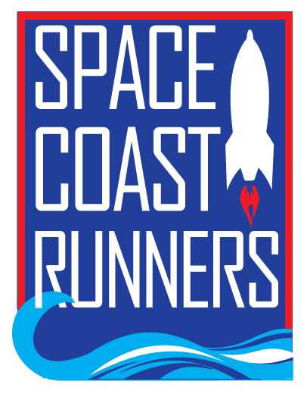

SPACE COAST RUNNERS
MINUTES OF April 2024 MEETING
6:30 PM EST – In Person Meeting
St Francis Reflections Board Room: 6905 N. Wickham Rd., 3rd Floor.
Monday, April 15th, 2024

Board Members / Officers Present: Terry Ryan (President), Brittany Streufert (Director of Operations), Galyn Sehnk (Vice President), Chris Kelly, Kelly Kervin (Secretary), Nicole Cash-Ianello, Steve Hebert, Donna Arnister and Alex Lipford
Board Members Virtual: Stephen Bernstein, Vish Ramachandran, Paul Boucher (Treasurer) and Johanna Ramirez
Meeting called to order at 6:32 PM
- Review of March Meeting Minutes – MTA from Terry, 2nd by Chris. Passed.
  - Terry questioned the time listed for Celebration Night. Kelly will change from 4-6 PM to 4-7 PM.
- Treasurer’s Report – Paul
  - December Treasurer’s Report - MTA Steve, 2nd Alex. Passed.
  - January’s Treasurer’s Report - MTA Steve, 2nd Alex. Passed.
  - February’s Treasurer’s Report - MTA Steve, 2nd Alex. Passed.
  - March Treasurer’s Report – MTA Steve, 2nd Terry. Passed.
    - The Driven is not sending payment in a timely manner. The board agreed to explore other hosting options for the club’s website.
    - Paul has been looking into banks for the club to move to. He is recommending Chase Bank based on weekend hours, debit card access and rates.
    - Alex MTA to approve the change to Chase Bank, 2nd by Steve. Passed.
    - The Executive Board will be the signatures on the account.
    - Paul is willing to mentor a treasurer trainee for the 2024-2025 BOD cycle.
- Direction of Operations Report – Brittany
  - Membership is 1,037
  - Training Camps
      - The 16-week Training Camp is moving to speed word to prepare for the EMC 5K.
  - Retail
    - Sold $1225.40 in March.
  - The next random runner will be selected from the Eat My Crust 5K. Keith is the photographer.
  - Celebration Night
    - Tickets are now on sale.
    - Brittany will get a quote from Mr. Delicious for food.
    - Brittany requested help collecting donations for raffles.
    - Golden Shoe, Hall of Fame and Lifetime Achievement nominations are due by April 17th.
  - Space Coast Marathon registration is stronger this year than it was at the same time in 2023. BibRave will be handling digital marketing.
  - Sponsorships
    - Sponsorship Packets are now available.
  - Corporate 5K
    - Rescheduled due to weather.
  - Big Peach Running Co invited SCR to table at their Grand Opening weekend.
- Committee Reports
  - Social – Johanna
    - SR520 Clean Up date is moving into May.
    - Working on volunteers for the Mixed Relay Night.
  - Race Committee – Kelly
    - Move for it 5K $500 Sponsorship MAM Donna, 2nd Donna. Passed.
    - Rainbow Run 5K $500 Sponsorship MAM Alex, 2nd Donna. Passed.
    - Kelly abstained from both votes because she wrote up the sponsorship proposals.
  - Youth Series – Donna
    - 314 youth races completed at least one race; 36 youth races completed the whole series.
    - Donna would like to buy a clock to use for the Youth Series. Brittany is going to ask Running Zone if they have a used one for sale.
    - Donna asked for thank you cards for sponsors and Brittany has them.
  - Race Results – Steve
    - Results were placed in the drive.
- President’s Report – Terry
  - Space Coast Classic 15K & 2 Mile
    - Registrations were at 589, 502 crossed the finish line.
    - So far, the feedback has been positive.
  - MAM to not partner with One Medal by Kelly, 2nd by Alex. Passed.
  - The board discussed the Conflict-of-Interest contract and the use for the 2024-2025 BOD.
  - The board discussed Terry’s replacement in 2026.
  - The RRCA Conference is being held May 2nd-5th and Terry is attending.
  - Brittany is still collecting individual bags of goldfish through Eat My Crust.
Motion to Adjourn by Terry 2nd by Nicole by Meeting adjourned at 8:07 PM

