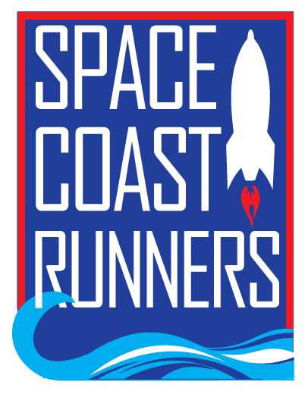

SPACE COAST RUNNERS
MINUTES OF JANUARY 2024 MEETING
6:30 PM EST – In Person Meeting
St Francis Reflections Board Room: 6905 N. Wickham Rd., 3rd Floor.
Monday, January 16th, 2024

Board Members / Officers Present: Terry Ryan (President), Brittany Streufert (Director of Operations), Galyn Sehnk (Vice President), Donna Arnister, Chris Kelly, Kelly Kervin (Secretary), Nicole Cash-Ianello, and Vish Ramachandran
Board Members Virtual: Johanna Ramirez
Board Members Absent: Stephen Bernstein, Paul Boucher (Treasurer), Alex Lipford and Steve Hebert.
Meeting called to order at 6:34 PM
- Board Member Resignation – Terry
  - Bambi Sweeney requested to be removed from the board. MTA to accept the resignation by Kelly , Nicole 2nd. Passed.
- Review of December Meeting Minutes – MTA from Terry, 2nd by Donna. Passed.
- Treasurer’s Report – Terry
  - Delayed due to Paul’s absence. MTA to delay the January treasure’s report to February by Terry, 2nd by Nicole., Passed.
- Direction of Operations Report – Brittany
  - Membership is 1,041
  - Training Camps
      - Couch to 5K was cancelled due to lack of interest.
      - 16-week Training Camp kicks off tomorrow with 75 participants plus pacers.
      - Coach Chris is considering a youth camp where they would meet multiple times a week. Brittany said Chris has gone through the Safe Sport Training but because it would oversee youth participants, the club should do a background check.
      - Brittany is still putting together a proposal for a free cross-country summer camp for local runners.
  - Retail
    - Sold $371 in December.
  - The next random runner will be selected from the Tooth Trot 5K. Brittany is going to ask if they have a photographer, if not, we will need to get someone.
  - Space Coast Marathon
    - The club should receive the financial breakdown in February.
    - Early registration opens next weekend, members will need to be active no later than Thursday, January 18th to be eligible for the early registration discount.
  - Brittany is working to get Donna an updated insurance certificate for the Youth Series.
  - Lululemon Group Run planning is still ongoing.
  - The Delray Beach Master’s Team event was cancelled.
  - Weekly runs in Palm Bay, Wickham and Cape Canaveral are ongoing. Brittany and Terry are speaking with potential organizers in Titusville and Cape Canaveral. Galyn expressed an interest in setting up a run, but location is TBD. Kelly asked if we would put together a flyer advertising our weekly group runs, instead of the local group runs around the county, and that is in the works. Terry asked about linking the weekly runs on our website and Brittany said it had been uploaded and explained where to find it.
  - Eye of the Dragon/Tail of the Lizard registration is strong, Slay the Beast Challenge is at 75% and expected to sell out again.
  - The SCR Christian Lake Memorial Scholarship would like one SCR Board Member to read. Donna Arnister will be the board representative. Terry asked about making the scholarship renewable, Brittany said the Scholarship fund would need to be over $40,000 before that was a consideration.
- Committee Reports
  - Newsletter – Chris
    - Chris is about to be ready to issue the latest newsletter.
    - Brittany and Chris talked about transferring the newsletter into the weekly email blasts. It is difficult to find relevant information for the newsletter because it is often already blasted out weekly.
  - Race Committee – Kelly
    - The Race Committee met earlier in the month to look over the race applications for the 2024-2025 Series and formulate a race calendar proposal. MTA to accept the proposed calendar by Nicole, 2nd by Galyn, Passed. Terry abstained due to conflict of interest.
    - The Race Committee also proposed a change in the ROY series points course from the North Half Marathon to the South Half Marathon. MTA to change the points earning course from North to South in 2024 by Kelly, 2nd by Nicole. Passed.
    - Race Sponsorship Proposal was submitted to the board to sponsor the Aktive Legacy 5K, Emerald City 5K, Autism Coalition 5K, and Superhero 5K & 1 Mile. MTA to accept the race sponsorship proposal by Donna, 2nd by Galyn. Passed.
  - Youth Series – Donna
    - The Youth Series received a $100 sponsorship from the organization Runner to Runner
  - Social – Johanna
    - SCR is scheduled to pack food bags for the Child Hunger Project on February 7th. Seven of Thirty slots are filled. Brittany will continue to blast the link for volunteer sign ups.
- President’s Report – Terry
  - Florida Marathon Water Stop
    - Brittany will set up a dedicated sign-up page for SCR members to volunteer. Need 16 volunteers for 2 shirts to cover 2 water stops.
  - Membership Verification
    - A non-member contacted Brittany on December 11th after they signed up to run all the races but didn’t understand that the membership was separate. They asked for backdated series points on the first three races, they signed up for a membership before Run Run Santa so they earned points on that race. Brittany explained our policy doesn’t allow for backdated points. When the issue escalated, it was brought to the Race Committee who also voted not to backdate points. It was then escalated to SCR President Terry Ryan. Discussion ensued about the situation and the board agreed to follow the stated rules and not to backdate points. If this individual continues to run the races which they’ve already paid for, they are still eligible for an age group award.
    - Terry asked if there was a way to do membership verification through RunSignUp in the future, but Brittany explained that membership is always changing so you’d have to reupload the database every time someone signed up so it’s not an ideal method.
  - Space Coast Classic 15K & 2 Mile
    - Registrations have been up over the last year.
    - Sponsorship packet is ready to go. Terry asked for help soliciting sponsorships.
    - Terry also asked that the board also hype up the location change from Viera to Cocoa.
- New Business
  - Kaitlin Donner is competing at the Olympica Trials on February 3rd at 10 AM. Brittany is planning to attend. Brittany asked if the club would like to consider sending her anything as a good luck/congratulation because it is the Olympic Trials and she is a coach for SCR. MTA to approve a gift up to $100 by Kelly, 2nd by Vish. Passed.
Motion to Adjourn by Terry 2nd by Kelly by Meeting adjourned at 8:02 PM

