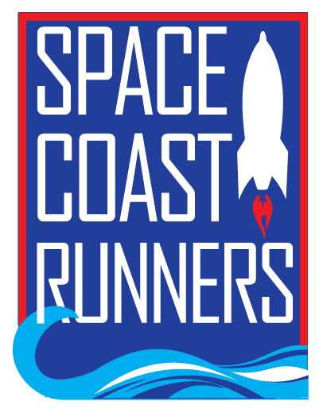

SPACE COAST RUNNERS
MINUTES OF OCTOBER 2023 MEETING
6:30 PM EST – In Person Meeting
St Francis Reflections Board Room: 6905 N. Wickham Rd., 3rd Floor.
Monday, October 16th, 2023

Board Members / Officers Present: Terry Ryan (President), Paul Boucher (Treasurer), Brittany Streufert (Director of Operations), Galyn Sehnk (Vice President), Donna Arnister, Chris Kelly, Kelly Kervin (Secretary), Nicole Cash-Ianello, Stephen Bernstein, Steve Hebert, Johanna Ramirez Bambi Sweeney, Alex Lipford and Vish Ramachandran
Board Member via Google Meet: Chris Kelly
Guest: Amanda Charles
Meeting called to order at 6:32 PM
- Review of September Meeting Minutes – MTA from Steve, 2nd by Stephen. Passed.
- Treasurer’s Report – Paul
  - Preliminary report, full report is delayed due to tax preparation.
  - Moving banks is incoming, Paul will leave behind a small sum to close out the account.
  - Preliminary 2024 Budget is expected at the November meeting.
  - MTA Preliminary Budget Report Steve, 2nd by Stephen. Passed.
- Direction of Operations Report – Brittany
  - Membership is 1,020
  - Training Camps
    - 16 Week Fall Camp doing great, no updates.
    - Let’s Go! Holiday Camp starts November 1st, aimed at beginning runners. Only has 1 registration so far, Brittany is exploring options on how to best market this camp.
  - Retail
    - Sold $903 in September.
    - Brittany is still trying to source reasonably priced toddler/youth shirts.
  - Random Runners was selected for Sprint for Sight 5K.
  - Space Coast Marathon
    - Bambi and Amanda both expressed concerns about the South Course being advertised as a “party course”. Discussion ensued. Brittany will talk to John and Pete about the feedback they’ve gotten.
    - Brittany said the prize wheel options are limited and asked for additional money to source promo items. Steve MAM to approve up to $1,000 on promotion items, 2nd by Terry. Passed.
    - SCR will be able to put up 2 tents this year to shield retail and the prize wheel from the sun.
    - SCR Retail Pop Up Shop is scheduled for 11/19 at Oars and Paddles. This will allow members to buy items ahead of Marathon Expo.
  - Paul expressed concerns that our advertising rate is too low. Brittany will email the rate card so everyone can view it and provide feedback.
- Committee Reports
  - Race Results - Steve
    - Races continue to bounce back from the pandemic slump.
    - Sprint for Sight saw a 362% increase this year.
    - Alex expressed concerns for the way the Men’s overall scores were on the website. Brittany fixed it.
    - Steve will need a trainee to take over race results and analysis and ROY scoring.
  - Social - Johanna
    - Halloween Run is scheduled for 10/26 at 6 PM at Wickham Park
    - Hydration goes south on 10/29
    - Winter Social is scheduled for January 14th at 8 AM, at Oars and Paddles
    - Dirty Oar Happy Hour Friday Social tentatively schedule for 11/17
  - Youth Series - Donna
    - Next race is 10/21 at Merritt Island HS
    - Donna is very happy about the new speaker system.
  - Master’s Team – Stephen
    - 10/22 Martin County
    - 10/28 Ormond Beach
    - 11/5 Golden Age in Sanford
    - Brittany has fielded a question about shot put. This information is being transferred to Stephen and Jeff.
- President’s Report – Terry
  - SCR is getting new podium boxes and Terry wanted feedback on the design. Kelly suggested putting rockets on them with the place inside the rocket for 1st, 2nd and 3rd.
  - SCR Sponsored Races coming up are Ghostly Gecko 5K and Dash 5K.
  - December’s meeting will be on 12/18 at St. Francis’ meeting room.
  - November meeting was moved to the 2nd Monday to accommodate the holiday.
Motion to Adjourn by Kelly 2nd by Alex by Meeting adjourned at 7:41 PM

