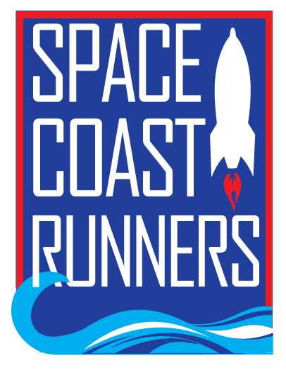

SPACE COAST RUNNERS
MINUTES OF December 2022 MEETING
6:30 PM EST – In Person Meeting
SFR Board Room, 6905 N Wickham Rd, Melbourne, FL
Monday, December 19th, 2022

Board Members / Officers Present: Paul Boucher (Treasurer), Brittany Streufert (Director of Operations), Donna Arnister, Kelly Kervin (Secretary), Bambi Sweeney, Chris Kelly, Kayla Cain, Galyn Sehnk, Terry Ryan (President), Steve Hebert and Johanna Ramirez
Board Member Present (Online): Ann Yarbrough, Stephen Bernstein, Rachel Weeks (Vice President)
Absent: Danielle Grose
Guest: Marisa Flint
Meeting called to order at 6:38 PM
I. Review of November Meeting Minutes – Reviewed. MTA Galyn Sehnk, 2nd Bambi Sweeney, All Approved
II. Treasurer’s Update & 2023 Budget Review – Paul
- November’s report is preliminary because it arrived late.
- Paul plans to have a budget to actual by the end of the week.
- Terry asked if SCR had to spend all profit as a non-profit?
  - Paul said no. There can be a profit if it isn’t excessive.
- Galyn asked what Square and Driven fees were?
  - Driven is the web host for SCR and Square is the credit card processor used for retail.
- Kelly asked how much was left for charitable donation in the 2022 budget.
  - Paul said $1,900.
- Paul said he is conservative on income to ensure there isn’t a shortfall at the end of the year.
- Ran All Races breaks even because SCR takes in the registration and then pays out to each race
- The SCR Training Camp is close to breaking even. It fluctuates depending on how many late registrations and non-members sign up.
- Brittany asked if we wanted to raise the membership fee?
  - Kayla asked if we could add another membership level for those with larger families. The answer was no, because of our website.
  - Donna said she didn’t think it was needed.
  - Stephen asked about reducing the fee but the fee goes towards the driven fees and new member packages. Each package includes a shirt and costs around $6 to mail.
  - Board agrees not to raise the membership fee in 2023.
- Retail sales in 2022 were $12,800; this is well above the projected retail income. Budget was adjusted to expect $7,500 in retail sales and $3,300 in cost of goods. Up from $6,000 and $3,000 respectively.
- Youth Series has seen a significant increase in participation this season. Twenty-five kids are on track to complete the whole series.
- Steve Hebert asked if the $5,000 previously allocated to fund high schools tracks is going to be reallocated?
  - Paul has pulled it out of the budget for 2023 and it has been absorbed in other areas.
- SCR has a sponsor who will print material as a donation. Brittany plans to use them when we reprint promotional materials.
- Chris asked if the projected negative budget was normal.
  - Paul said yes, it balances out by the end of the year and SCR ends in the black.
- Overview of Budget changes:
  - Silver Sponsor line item was added at $500.00
  - SCR Races (EOD & SCC) went up from $1,200 to $2,000
  - Celebration Night Rental went up from $300 to $500
  - Cocoa Village Sundays went up from $3,500 to $3,800
  - Youth Series went up from $2,500 to $5,000
    - Donna plans to apply for the Track Shack Grant again
  - Square Fee went to $300 from $240
  - ROY Series Award went up to $1,350 from $800
- 2023 Budget MTA Donna Arnister, 2nd Kayla Cain, All Approved
III. Operations Director – Brittany
- Membership
  - Membership is up from last year
- Retail
  - $12,800 sold to date.
  - Retail will be open during the Run Run Santa 1 Mile
  - Run Run Santa 1 Mile Donation Request
    - $250 for a hot cocoa/coffee bar due to the unusually cold weather
    - Signage thanking SCR will be put up
    - MTA Steve Hebert, 2nd Galyn, All Approved
  - Space Coast Marathon
    - One phone call complaint about clean up, but it appeared to be trash that fell out of a garbage bin
    - Kayla said the volunteers at the banana station were on their phone and not breaking up the bananas to make grabbing easier
    - Johanna said she heard complaints about the lack of water on the north course.
  - Training Camps
    - Spring camp registration is open.
    - SCR is debuting a new Couch to 5K program.
      - Registration is going slower than anticipated.
IV. President Report - Terry
- Race Sponsorship Proposal- Kelly
  - Kelly proposed sponsoring five local races that take place in the first quarter of 2023. The list was approved by the race committee.
    - Aktive Legacy 5K
    - Autism Awareness 5K
    - Chuck Wagon 5K
    - Briana Marie Foundation 5K
    - Gateway to Space 5K & 10K
  - MTA Paul Boucher, 2nd Stephen Bernstein, All Approved, Kelly Abstained
- Board Member Conflict
  - A current board member will have a scheduling conflict due to school. The board member will still do the results and scoring for the series. After board discussion everyone agreed that the board member would remain on the board even though they will be absent from the meetings through May.
V. Upcoming Events – Johanna
- Winter Social
  - Winter Social is on Sunday, January 15th at Oars and Paddles
  - Each board member is asked to put together a raffle prize.

VI. New Business
1. Scholarship – Marisa Flint
a. SCR gives out two $2,000 scholarships each year.
b. To quality you have to be a SCR Member or a member of their high school cross country or track & field team.
c. Applicants must write a 250 word or less essay based on a provided prompt
d. Bambi, Galyn, Steve, Stephen, Kelly and Kayla all volunteered to read
Motion to Adjourn by Donna Arnister, 2nd by Kayla Cain. Meeting adjourned at 8:43 PM.

